1. Setup a virtual machine using Ubuntu image.

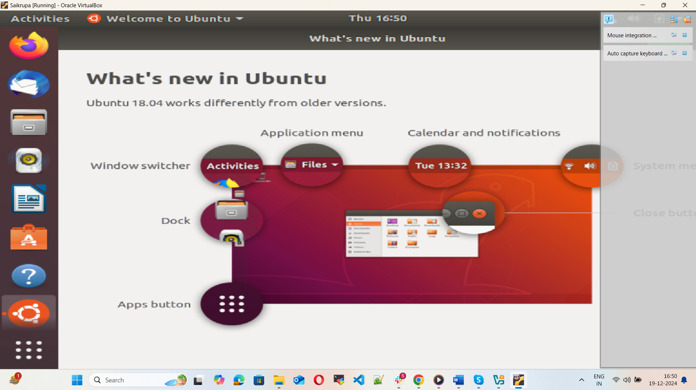

1. Install docker on ec2.

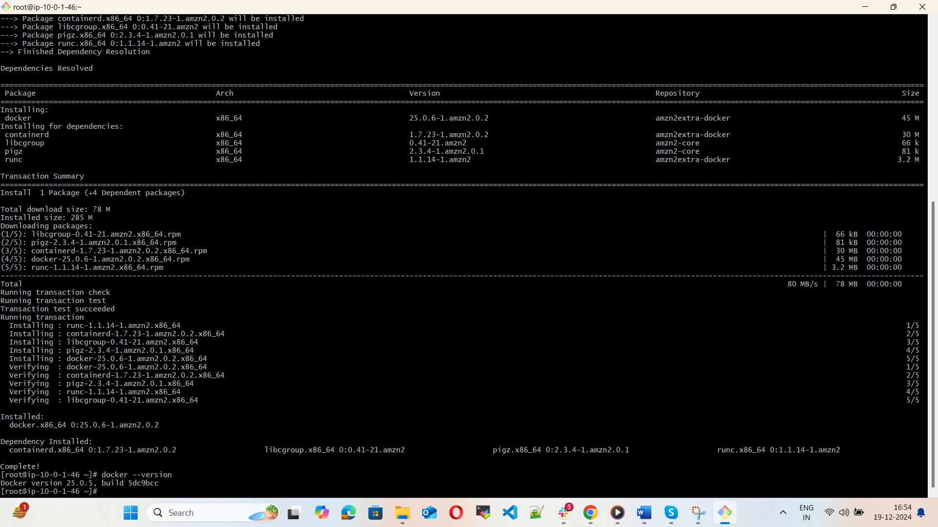

1. Pull 5 docker images. (Nginx, Apache tomcat, ubuntu, Jenkins, SonarQube)

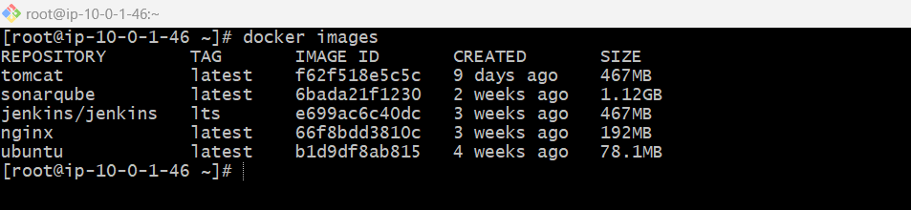

1. Run nginx container and expose on port 81.

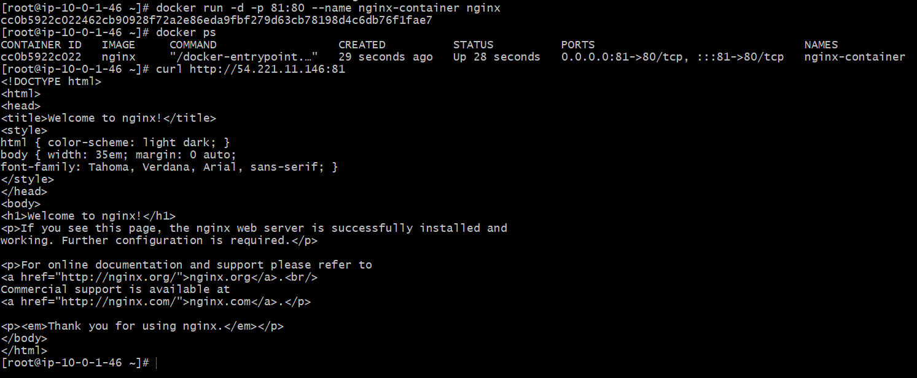

1. Delete the Apache tomcat image from local.

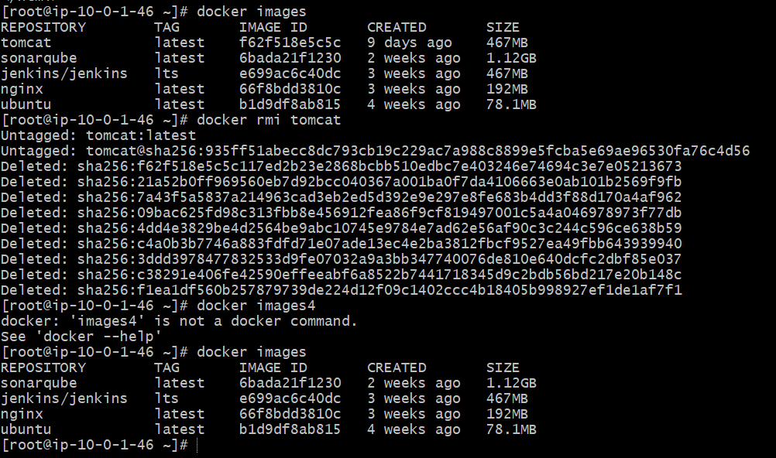

1. Inspect the Jenkins image, SonarQube image.

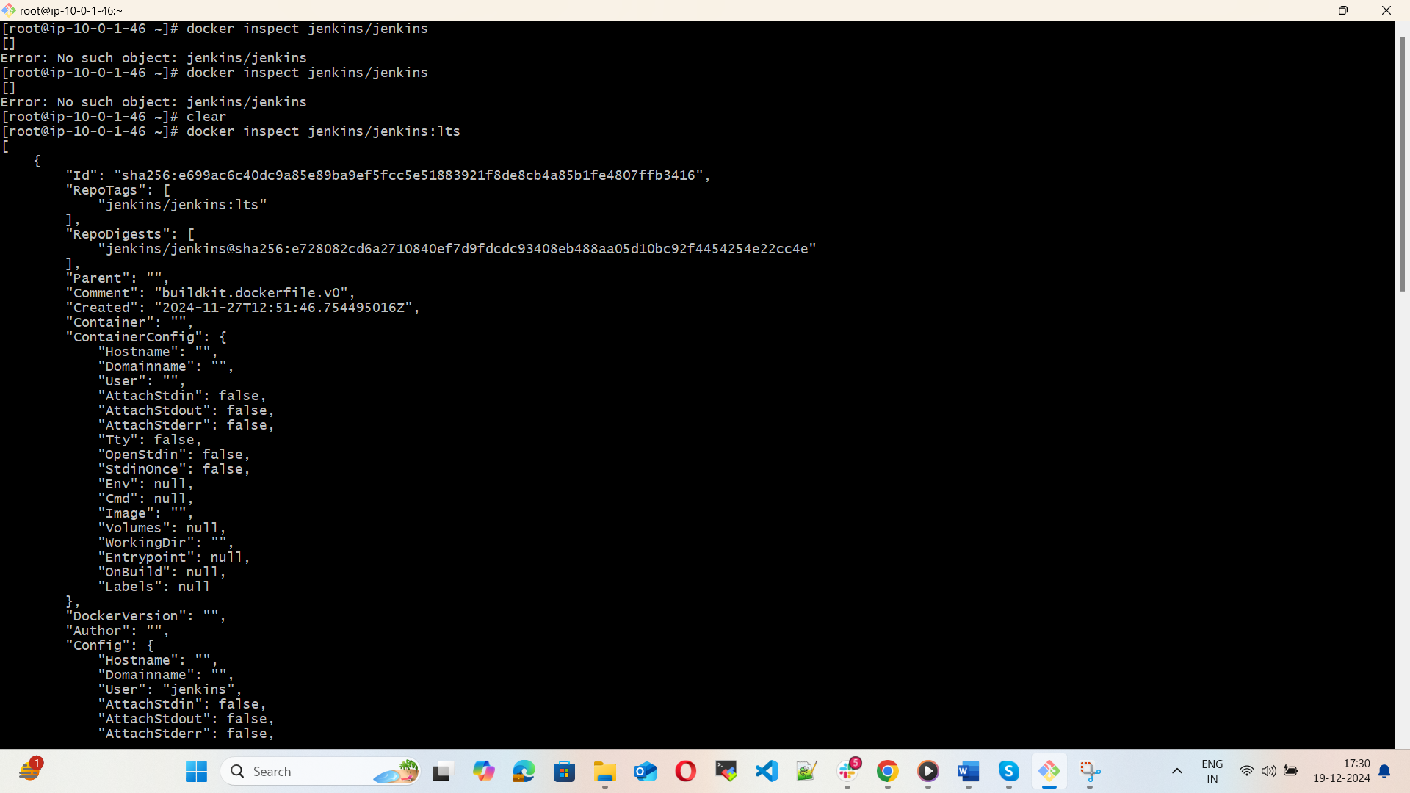

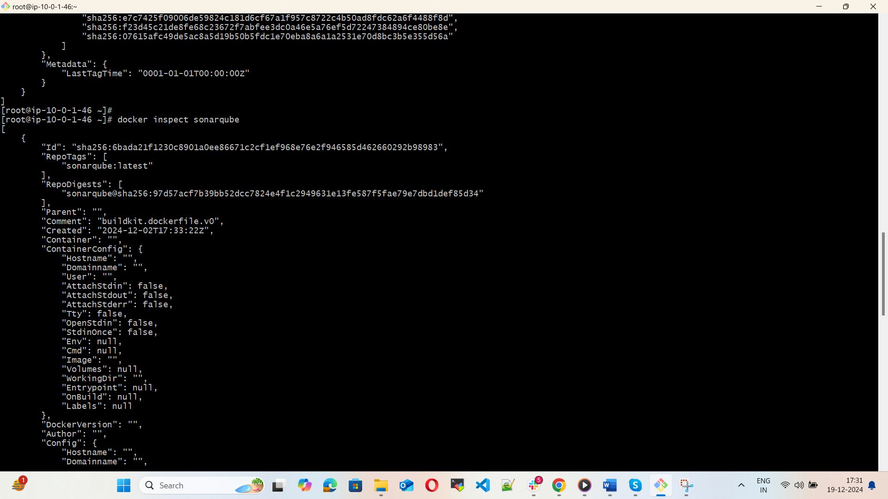

1. Run Jenkins container and run one sample job.

